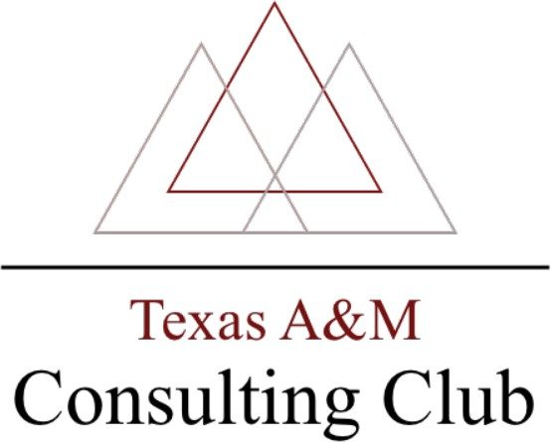

Mays 2022 TAMU Case Challenge
The Mays 2022 TAMU Case Challenge is the largest on-campus student-run case competition at Texas A&M University. Each year, ~16 teams compete to solve a business
problem and present their solutions to a panel of real consultants from big name consulting firms. Teams will consist of four students - you may apply to the competition as either a team or an individual. If you decide to apply as a team, you will only need to complete one “TEAM
APPLICATION” on behalf of your teammates (neither you nor your teammates will need to complete individual applications) If you apply as an individual, you will need to complete an “INDIVIDUAL APPLICATION,” which includes a few short answer questions to provide us
with information to place you on an appropriate team. Applications can be found and completed on the Texas A&M Consulting Club website (tamuconsultingclub.com/competition).
Participants will have the opportunity to network with industry professionals, gain insight into the consulting world, and develop practical case skills. Undergraduates of all majors and disciplines are welcome.

IMPORTANT INFORMATION
The competition will be held in the Cocanougher (WCBA)
- The day of the competition (Friday, April 8th), the Networking Session will be held from 11:00 AM – 12:30 PM. This time is an important time to network with judges.
Attending is a REQUIRED aspect of the competition, unless you have class or other extenuating circumstances.
- Participants are required to wear Business Professional attire
- The 4 final teams will present their case in front of all participants after lunch
- A maximum of three seniors are permitted per team
- APPLICATIONS ARE DUE ON March 23ND at 11:59 PM.
- If you have any questions, please contact: tamutxcc@gmail.com

PLEASE NOTE: We understand that you have classes - you do not need to be present for the entire day. However, please be mindful of your class schedule when you indicate preference for presentation times in your application.

Schedule of Events: Friday, March 12th, 2020
Time | Schedule | Location
8:15 AM | Check-In Begins: Attendance is required by at least one team member. | Cocanougher
8:30 AM | Introduction Meeting: Attendance is required by at least one team member. | Cocanougher
9:00 AM -  11:00 AM | Presentations: Your team will be assigned a 30 minute time slot in the presentation schedule. In  your application, you may indicate which slots you are available and unavailable for. | WCBA
11:00 AM | Judges Deliberate | WCBA
11:00 AM | Lunch Break | Cocanougher
11:20 AM | Networking Session | Cocanougher
12:20 PM | Top 3 Teams Announced | Cocanougher
12:30 PM | Finalist 1/4 Presents | WCBA
1:00 PM | Finalist 2/4 Presents
1:30 PM | Finalist 3/4 Presents
2:00 PM | Finalist 3/4 Presents
2:30 PM | Judges Final Deliberation | WCBA
2:40 PM | Awards & Closing Announcements | Cocanougher

